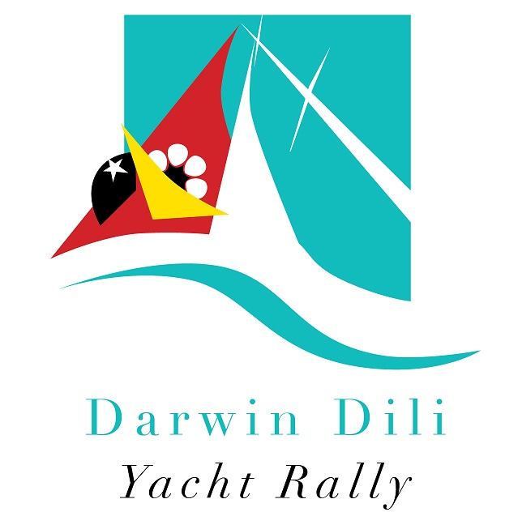

2015
Darwin Dili Yacht Rally
11 July 2015

PRE-ENTRY
Information Booklet

Issue 1 of 17 February 2015

Important Pre-departure Dates

At least one (1) week  before departure | Go to Australian Customs and arrange for outward clearance | Page 5
Sunday 5 July  1400 hours | Rally Technical Briefing , Training Room, Darwin Sailing Club, Atkins Drive, Fannie Bay | Page 4
Sunday 5 July  1800 hours | Farewell BBQ for participants at Darwin Sailing Club | Page 5
Thursday 9 July | Closing date for JR Duty Free orders delivered to DSC. | Page 6
Friday 10 July  0900-1100 hours | Attend Australian Customs Outward Clearance at Darwin Sailing Club  Opportunity to submit completed Timor-Leste Immigration and Customs forms to Rally organisers for pre-clearance | Page 5
Saturday 11 July  1100 hours | RALLY START | Page 8

Document Control – Rally Information Booklet
Issue # | Title | Date | Mode
Issue 1 | Pre-Entry Information Booklet | 17 February 2015 | Electronic
Issue 2 | Information Booklet Update | Approx 1 month prior to Rally Start | Electronic
Issue 3 | Information Booklet Final | 5 July 2015 at Technical Briefing | Electronic and Hard Copy

Updated Information provided in Issues 2 and 3 of this Rally Information Booklet will be highlighted in the Contents Section of the document.

Email: mail@sailtimorleste.org

Web: www.sailtimorleste.org

CONTENTS
Welcome to the 2015 Darwin Dili Yacht Rally | 2
Purpose of Document | 2
How to Enter the Rally | 2
Entry Fee | 3
After the Dili Rally – extensions into Indonesia available | 3
Technical Briefing | 4
Farewell BBQ | 5
ID Tags | 5
Australian Customs | 5
Duty Free Fuel | 5
Yacht Identification | 5
Vaccinations and Medications | 5
Duty Free Ship stores | 5
Before Departure | 6
Time Zones | 6
Sailing Instructions | 6
Rules and Safety | 6
Divisions, Handicaps and Prize Money | 7
Rally Communication | 7
The Start | 8
The Course | 8
The Finish | 8
After Finishing | 8
Timor-Leste CIQP and Other Arrangements | 9
Dili Arrival CIQP | 10
Visas on Arrival and Sailing Authorisations (Cruising Permits) | 10
Crew joining your yacht in Dili | 11
Dili Beach Security | 11
Official Program in Dili | 11
T-Shirts | 12
Other Important Matters | 12
Dress in Timor-Leste | 12
Cruising after Dili | 12
Diesel Fuel, Water and Gas | 13
Yacht Spare Parts | 13
Shower and Toilet Facilities | 13
Internet Facilities | 13
Garbage Disposal | 13
Dili Guide | 13
Emergency Contacts in Timor-Leste | 11
Yachts Returning to Australia | 15
What the Rally means to Timor-Leste | 15
Generosity | 16
Feedback | 16
Attachments:
- Start Line in Darwin | 17
- Jaco Island Time Gate | 18
- Finish Line in Dili | 19
- Anchorage Area in Dili | 20
- Sailing Instructions | 21
- Online Entry Instructions and Check list | 27
- Yachts Participating in BOTH the Dili and Sail Indonesia Rallies | 29
- Australian Customs Service – Yachts returning to Australia | 31
- Timor-Leste Forms and Requirements | 32
- Timor-Leste Sailing Authorisation | 33

Welcome to the Sail Timor-Leste
2015 Darwin Dili Yacht Rally
Welcome to the 2015 Darwin Dili Yacht Rally.
Since its re-establishment in 2010, the annual Darwin Dili Yacht Rally is a major celebratory event in Timor-Leste’s calendar of events. It is auspiced by the Timor-Leste Government Ministry of Tourism.
Timor-Leste welcomes visiting yachts to its shores. The Darwin Dili Yacht Rally is an important event for Timor-Leste, not only because of historical linkages but because of its potential to grow and meaningfully contribute to the development of the Timor-Leste marine tourism industry.
Timor-Leste’s primary objective in the 2015 Darwin Dili Yacht Rally is to ensure that all participants have the best time possible so that you spread the word about the event and attract more yachts to visit in future years. We look forward to welcoming you to Timor-Leste.
The rest is up to you!
Purpose of Document
This document will provide you with all necessary information related to the Rally including: Rally entry, Australian Customs clearance and other departure arrangements from Darwin, entry into Timor-Leste and your arrival in Dili (as well as the other places you will visit in Timor-Leste) and your exit out of Timor-Leste. This information is for you and it is important so we ask that you take the time to read it thoroughly.
The information contained in this document and all information Sail Timor-Leste provides to you in our publications and on our website www.sailtimorleste.org is the OFFICIAL information, regarding such matters as Visa extension, cruising regulations, entering and leaving intermediate ports in Timor-Leste, checking out from Timor-Leste etc.
Please also use the website www.sailtimorleste.org as a source of general information about the Rally and Timor-Leste. It contains a wealth of information and relevant links.
The Sail Timor-Leste Darwin Dili Yacht Rally is a web based event, organised and managed using the internet and email only; we do not use telephone, mail or facsimile. Please always include the name of your yacht in the subject line of all emails to us.
How to enter the Rally
Entries for the 2015 Rally will open in March 2015 and will be via an On-Line entry form. Instructions for entry and an entry checklist are shown at pages 27 of this document and on our website.
We will email you when entries open and provide instructions for creating your Rally account. Using the on-line entry form enables you to change or update information right up to the time that entries close (estimated 14 June 2015). You can also generate Crew Lists from your entry.
Electronic copies of the following documents are required as part of your entry for 2015 Darwin Dili Yacht Rally. Entries will not be considered complete until all attachments and information have been received.
a) A digital scan of your yacht's current Official Ship’s Registration;
b) A digital scan of the details page of all crew passports, including the skipper;
c) The name and contact details of Next of Kin for each crew member, including the skipper;
d) A digital Passport-style photo of the skipper/captain;
e) A digital photo of the vessel; and
f) A scanned copy of evidence supporting your payment of the AUD250 entry fee. Please include your Yacht’s Name on the document. Details of the bank account for entry fees will be advised on the entry form.
g) If you have a current IRC or OMR rating, a copy of this rating certificate is also required.
The Rally Committee will review the online entry details and match the entry, supporting documentation and accompanying payment as soon as practical.
If entry, supporting documentation and payment are correct, an email confirmation will be sent out. If entry, supporting documentation and/or payment are not complete a follow up email will be sent out
Names of confirmed entries will be listed on the website. If the entry is still not complete, the listing on the website will be shown in RED as follows: ***Yacht Name***
Due to the physical limitations of Dili Harbour, the Rally fleet will be limited to a maximum of 20 yachts. Entries will be accepted as they are received on a ‘first-in, first-served’ basis. Entries which are in excess of the 20 yacht limit will be placed on a waiting-list, pending any cancellations.
Your Entry Fee
An AUD$250 entry fee applies. It includes a donation of AUD$100 to the Marine Education Scholarship to promote skills development and capacity building to support Timor-Leste’s marine tourism industry. For further information on the Scholarship please refer to the website:
http://www.sailtimorleste.org/dili
A 30-day entry Visa costing USD$30 will be payable on arrival in Dili for each crew member.
The entry fee has been kept as low as possible, made possible by significant sponsorship of the Timor-Leste Government and businesses and the generous support of the NT Government which, collectively, are covering the costs of:
- The Rally barbeque and Technical Briefing in Darwin,
- Yellowbrick Yacht Tracker
- The Rally presentation and dinner in Dili with entertainment, dinner and cultural shows,
- Dili and districts tour
- Your Timor-Leste Cruising Permit, and
- Exemption from the Timor-Leste Port, Harbour and Quarantine Inspection Fees
Additional charges not covered by the entry fee are:
- Your Timor-Leste Visas or Visa extension fees
- Additional tour costs or connections
- Any other charges and costs during your stay Timor-Leste
- The cost of Indonesian Social Visas or Cruising Permits (if you intend taking your yacht to Indonesia afterwards).
After the Dili Rally – extensions into Indonesia available

Once you have arrived in Dili, you are free to:
- Stay and cruise in Timor-Leste waters for up to 3 months (Your 3-month Sailing Authorisation is extendable on application)
- Return to Darwin/Australia on your own timetable or
- Extend your voyage into Indonesian waters through the length of an amazing archipelago or simply visit a few magical Indonesian islands on your way back to Darwin.
Any yachts wishing to travel into Indonesian waters or ports require a Cruising Permit (CAIT) for your yacht that takes at least 1 month to process in Jakarta and must be obtained prior to departure from Darwin. Social visas for Indonesia for yacht crew can be obtained from the Indonesian Consulate in Darwin or from the Indonesian Embassy in Dili.

For those of you wishing to extend your voyage into Indonesia, special arrangements are available for participants in the Dili Rally through the 2015 Sail Indonesia Rally (see below). (Note: you do not have to follow the Sail Indonesia schedule to participate in their Rally – you can choose your locations, timetables and exit ports.). The cost of CAITs to visit Indonesia independently of any organised event is approximately AUD300-400, and can be organised through Sail Timor-Leste. Email us for further information.

The 2015 Sail Indonesia Rally

Sail Timor-Leste and Sail Indonesia work co-operatively to facilitate arrangements for yachts that wish to enter both events. (Note: you do not have to follow the Sail Indonesia schedule to participate in their Rally – you can choose your locations, timetables and exit ports.) For yachts first participating in the Darwin Dili Yacht Rally, there is a reduced entry fee of AUD$250 for the Sail Indonesia Rally as you will not be in Darwin for a number of pre-Sail Indonesia events. The normal Sail Indonesia entry fee is AUD$525.

The Darwin Dili Yacht Rally starts two (2) weeks prior to the Sail Indonesia Rally that leaves Darwin on 25 July. This will allow enough time for Dili Rally participants to spend a short while in Timor-Leste and its waters before sailing across the north coast of Timor Island onto Kupang in West Timor. This will allow you to join up with the Sail Indonesia fleet arriving in Kupang from Darwin.

Yachts participating in both events should depart Dili/Timor-Leste waters in time to reach Kupang in West Timor to coincide with the arrival of the Sail Indonesia fleet from Darwin, currently estimated to be 28 -31 July 2015. For more information go to www.sailindonesia.net

Refer to page 29 for details of entering both the 2015 Darwin Dili and Sail Indonesia Rallies.

Additionally, for yachts participating in both rallies, an informal cruise from Dili to Kupang is being organised. This will include a short stopover at the Timor-Leste enclave, Oecusse, which is located on the north coast of West Timor (approximate co-ordinates S09° 10' E124° 20'). Oecusse (also known as Pante Makassar) is almost equidistant from Dili and Kupang (approximately 90 NM from Dili and from Kupang). Oecusse will be automatically included on your Timor-Leste Sailing Authorisation so there is no need to decide about this destination in advance.

Finally, if you will be returning to Darwin/Australia after cruising through Indonesia, you are welcome to return to Timor-Leste waters and call in at Dili etc for another stay if you wish – you may need to renew visas etc but this is not difficult. On return to Dili, the first point of call is the Dili Port Authority/Harbour Master. You may email mail@sailtimorleste.org of your intentions to return to Dili and we will advise Dili Port; however you will still need to contact them directly on arrival to arrange your clearances.
Rally Information and Technical Briefing - Sunday 5 July at 1400 hours
The Rally Information and Technical Briefing will be held on Sunday 5 July at 1400 hours at the Darwin Sailing Club Training Room. Briefings will be given on the Rally and representatives from Timor-Leste will provide information on TL CIQ procedures, the program in Timor-Leste and cruising opportunities after leaving Dili. This will be followed by a question and answer session. This briefing is compulsory; the skipper and one other member of the crew must attend.
At this briefing the following items will be detailed:
- The Start and Finish procedures,
- Rally Divisions and Handicaps,
- Yellowbrick Yacht Trackers
- Timor-Leste Customs and Immigration procedures in Dili,
- The Rally events in Dili,
- Cruising in Timor-Leste, and
- Details of the proposed communication scheds for the duration of the leg from Darwin to Dili.
At the Technical Briefing the following items will also be handed out to participants:
- Information on Timor-Leste ports and anchorages
- The Rally pennant
- The Timor-Leste Courtesy Flag
- Timor-Leste forms and documents for your arrival
- Issue 3 of this Information Booklet
For yachts also participating in the Sail Indonesia Rally, there will be a further briefing on Sail Indonesia immediately afterwards.
Sail Timor-Leste Farewell Barbeque – Sunday 5 July at 1800 hours
There will be a complimentary barbeque at the Darwin Sailing Club on Sunday 5 July at 1800 hours for skippers and crews only. Dignitaries and officials from the Northern Territory and Timor-Leste Governments will be attending the function, but the dinner will be relatively informal.
A barbeque meal and some drinks will be provided. Sorry we don’t cater for special dietary needs but if a barbeque is not to your taste the Darwin Sailing Club bistro offers a wide range of food that can be purchased.
ID Tags
All participants in the Rally will be given Rally ID Tags when they attend the Farewell Barbeque. These ID tags should be worn/available at all official Rally events both in Darwin and throughout Timor-Leste.
Australian Customs – Outward Clearance Date is 10 July
Sail Timor-Leste will provide Australian Customs a list of all participating yachts and crew details after entries close.
Final clearance out of Australia will take place on Friday 10 July from the Darwin Sailing Club and must be attended by the skipper and all crew. Further details on the Australian Customs clearance procedure will be provided by email closer to the date.
Duty Free Fuel
The Australian Customs Service will provide instructions regarding duty free fuel and refund of GST. This information will be emailed to you by Sail Timor-Leste closer to the date.
Yacht Identification
All yachts will be issued with a Darwin Dili Rally pennant identifying them as Rally participants. The pennant should be flown across the Start Line in Darwin Harbour and not taken down until your yacht finally leaves Timor-Leste waters.
The Rally pennant is to ensure that when yachts enter Timor-Leste waters and visit intermediate ports in Timor-Leste after departure from Dili that they are recognised as Rally participants by officials and treated accordingly. The yacht's own national flag should be displayed at the stern and the Timor-Leste flag of a size not less that the yacht's own national flag from the crosstrees. When you enter Timor-Leste waters you must display the code flag "Q" until you have been cleared by Timor Leste Customs.
Vaccinations and Medications
In Timor-Leste Typhoid, Hepatitis, Tetanus and Malaria are common. Every crew member should consult a doctor for detailed advice on the prevention and treatment of tropical diseases. The Travellers Medical and Vaccination Centre located at 43 Cavenagh Street in Darwin on the first floor of the Cavenagh Centre and they specialize in tropical medicine and vaccinations. Their phone number is + 61 8 8901 3100 or email: darwin@traveldoctor.com.au ; usually there is a few days wait for an appointment.
A detailed health overview for travellers in Timor-Leste can be found at the following websites: www.traveldoctor.com.au and www.mdtravelhealth.com/destinations/asia/east_timor.php
Duty Free Ship stores
JR Duty Free offers an extensive range of products with free delivery to your yacht. JR Duty Free is located at Darwin International Airport next to Arrival Gate Number 7. Trading Hours Monday to Friday 0830-1600 hours. Phone (08) 8927 0255 Fax (08) 8927 0149 email jrdfdiabond@jamesrichardson.com.au or visit the website www.jrdutyfree.com.au.
Participants should note however that supermarkets in Dili sell an extensive range of international quality liquor, spirits and tobacco products at prices which are roughly equivalent or less than Australian duty free prices. If you are travelling on from Dili into international waters, arrangements can also be made to purchase duty free stores in Dili, at considerably cheaper prices.
Before Departure

Please check:
- That every crew member has six months validity on their passport from the date of arrival in Timor-Leste and at least two spare pages in their passport;
- Obtain relevant travel advice and special advisories from Department of Foreign Affairs and Trade (www.dfat.gov.au) or from your national embassy;
- That you have complied with all Australian Customs clearance requirements;
- Obtain medical/travel insurance in the event you require medical evacuation from Dili;
- Consider international roaming for your mobile;
- Obtain the necessary amount of US dollars or travellers cheques. The ANZ Bank and a number of other foreign banks operate in Dili but it is always advisable to arrange some cash or travellers cheques prior to arrival;
- Obtain any necessary prescription medicines and any necessary vaccinations and anti-malarial treatments;
- Obtain a Timor-Leste travel guide e.g. Lonely Planet or equivalent
- Take supplies of second hand children's clothes, notepads and pens etc to give away in return for the hospitality you will receive at small villages and communities.
- Learn a few words of Tetum! A smile and a few local words can take you a long way.
Time Zones
The Rally will operate on Darwin CST time until each yacht is cleared into Timor-Leste. CST is GMT +9:30, Dili time is GMT +9:00.
Sailing Instructions
Rally Sailing Instructions are shown on pages 21-26 and are downloadable directly from the website: http://www.sailtimorleste.org/ Yachts need to confirm compliance with the Sailing Instructions when they enter the event. Any changes to the Sailing Instructions will be notified at the Technical Briefing on 6 July.
Rules and Safety
The safety of the vessel and its crew is the sole responsibility of the skipper. The Rally is open to Monohull yachts having a waterline length of not less than 7.3 metres and Multihull yachts with a waterline length of not less than 8.0 metres. All yachts shall have completed a non-stop passage of at least 200 miles across open sea and must comply with the SOLAS regulations. A guide to recommended minimum safety standards are posted on the website: http://www.sailtimorleste.org/entry .
The Rally will be sailed under the International Regulations for the Prevention of Collisions at Sea.
Division II: The use of automatic steering is permitted in Division II, and when engine propulsion is used it must be logged, totalled and declared at the finish in Dili.
All other Divisions: The use of automatic steering is not permitted. Engine propulsion may only be used when rendering assistance to a vessel or crew in distress or to avoid imminent danger to the vessel or crew. Engine use and circumstances of use must be logged and reported as soon as practical to the Rally Committee who will adjudicate on its validity and determine the penalty (if any) to be applied.
Divisions, Handicaps and Prize Money
The following divisions are offered and unless you notify us in writing that you wish to enter a Competitive Cruising Division you will be automatically entered into the Cruising/Rally Division:
- Division I - Monohull Competitive Cruising yachts
- Division I – IRC - In the event that two (2) or more entrants in Division I possess a current IRC rating, an IRC Division will be declared.
- Division II – Cruising/Rally – open to any vessel, including both sail and motor vessels
- Division III - Multihull Competitive Cruising yachts
The Rally Committee reserves the right to make changes to and within Divisions; any such changes will be advised at the Rally Technical Briefing.
The Committee will allocate handicaps as follows:
- Yachts in Divisions I and III will be allocated a Time Correction Factor (TCF) based on the yacht's measurements and performance history (if any). The yacht's Elapsed Time will be multiplied by this TCF to give a Corrected Time and placings.
Any yacht with a valid/current IRC certificate or OMR rating must declare this and provide a copy with their entry.
- IRC Division yachts – the TCF on the yacht’s IRC certificate will be adopted to form handicaps for this division.
- Division II yachts – at the discretion of the Committee, Division II yachts may also be allocated a TCF which may be used to guide final award of placings.
The Government of Timor-Leste is proposing to offer a special prize pool for the event, as it has done annually since 2012. When this is confirmed, the value and allocation of the prize pool will be announced in an update to the Sailing Instructions and emailed to yachts with registered interest in the Rally.
Divisional prize pools will be confirmed following finalisation of Divisions at the Pre-Rally Technical Briefing and posted on the website.
Rally Communication and Reporting
Yellowbrick Yacht Trackers will be used as the primary reporting medium while the Rally is in transit. Yacht positions will be automatically uploaded to the progress page of the Rally website. These Yellowbrick yacht trackers are included in the cost of your entry fee.
However, as a secondary back-up, each yacht should possess either a:
- an HF Radio equipped with HF 4483 KHz (primary) / 2524 KHz (secondary) or
- a Satellite Phone or
- a satellite communication device such as a GPS Spot Device or a Delorme inReach Satellite 2-way Communicator
for the purpose of transmitting twice-daily yacht position reports to the Rally Committee until the yacht crosses the Finish Line in Dili. Yachts must also record their transit time through the Jaco Island Time Gate and transmit this to the Rally Committee. In the event that there is no wind along the coast of Timor-Leste, this time may be used to calculate final results.
Any yacht which is unable to comply with these communication requirements is asked to contact organisers as soon as possible. Position reporting is as much for your safety as it is for the peace of mind of family and friends ashore. The Rally website will be updated with the positions of all yachts after each sched.
From Com onwards to Dili, you will receive intermittent mobile phone coverage if your mobile has been activated for international roaming.
The Start
The Start will be on Saturday 11 July at 1100 hours in the area west of the Darwin Sailing Club as marked on the attached chart on Page 17. The Start Line will be between the start boat (details advised at the Technical Briefing) which will be in a position approximately 100-200 metres NNW of “F” buoy, located in the vicinity of 12° 25.52’ and 130° 48.14’. All Rally division yachts must keep clear of any yacht in a competitive division in their vicinity, particularly during the starting sequence.
The Start Vessel will carry out the following start procedure:
- 1050 Hours Warning Sound Signal; Code Flag "P" will be hoisted
- 1055 Hours Preparatory Sound Signal; Numeral Pennant 1 will be hoisted
- 1059 Hours Code Flag "P" will be lowered
- 1100 Hours Starting Sound Signal; Numeral Pennant 1 will be lowered .
Any recalls will be made over VHF radio on Channel 77.
The tides on 11 July are: a low of 3.29 metres at 0711 hours and a high of 5.52 metres at 1302 hours. Be aware that the Sail Indonesia fleet will be in town and the pre-start area is likely to be congested.
In keeping with tradition, there will be awards for the best presented crew and yacht and first over the start line under sail.
Any yacht having to return to Darwin after the Start, or does not Start, or is delayed in starting, should advise Australian Customs and Rally Organisers at the earliest opportunity.
The Course
The course is a distance of 425 NM from the Start Line in Darwin Harbour, Australia, leaving the Jaco Island (located approximately S8° 26’ and E127° 21.2) to port, to the Finish Line off the city of Dili, Timor Leste. Recommended charts for this passage are: Aus 26, Aus 313, Aus 4721, Aus 901.
A Time Gate has been established at Jaco Island. Yachts must record their time (CST Darwin time) when they pass through Longitude E127° 20’, after rounding Jaco Island (refer Page 18). This time should be reported to Organisers at the earliest opportunity. In the event that there is no wind along the coast of Timor-Leste, this time will be used to calculate final results.
The Timor-Leste Government has two new naval patrol vessels (Shanghai class III) from China. In a country with limited territorial waters, it is entirely possible that these naval patrol vessels will meet the fleet as they round Jaco Island (or before!) and provide escort all the way to Dili.
The Finish
The finish line is a transit of the longitude E125° 34’ between the drying reef bounding the northern edge of Dili Harbour and the latitude S8° 32’, as marked on the attached chart on Page 19. The finish line is about 500 metres in length.
When you pass Fatocama Point (approximate longitude of E125° 36.2) as you approach the finish line, contact the Dili Rally Office in Dili on VHF Channel 77 for any final directions. Yachts must take their own finish time (CST Darwin time) and advise the Dili Rally Office by radio (VHF Ch 77 and/or GPS SPOT message).
After Finishing
When ready, you may enter Dili Harbour and approach the rally anchorage (page 20). Extreme care should be exercised as you approach and traverse Timor especially close to Dili as it is a working port.
- Dili Harbour is surrounded by fringing drying reefs, and must be entered between the designated port and starboard channel markers.
- After entering between the designated port and starboard channel markers you will notice 2 yellow quarantine buoys on your port side. These are NOT to be used by Rally participants.
- If approaching at night you will notice in the same area the reef (as shown on the charts) will be lit by flashing white strobes: one strobe on the western extremity of the reef, one strobe on the eastern extremity of the reef and one strobe on the yellow Quarantine Buoy in the middle (this buoy has moved during heavy weather and now sits on top of the reef!).
- You may then proceed to the rally anchorage on the port side of the main wharf. The CIQ/Rally anchorage is located at approximately S8° 33.10’ and E125° 34.5’ as marked on the attached chart on Page 21. Please use extreme caution if entering the Rally anchorage at night particularly in the event that Murphy is in operation, and the strobes have failed.
- The following flags must be hoisted: Code flag Q, Timor Leste courtesy flag, Darwin Dili Rally pennant.
- Dili Bay Moorings - Moorings in Dili Bay are currently being inspected and refurbished and may be available for use by Rally yachts free of charge. Use of the moorings is not compulsory and yachts may elect to anchor instead. However Rally Organisers make no warranty as to their fitness for purpose. Yachts which use the moorings do so at their own risk.
- Yachts arriving during daylight hours may be met by a tender and guided to available moorings. Yachts arriving by night are advised to anchor until the following day when they may be guided to a mooring.
- Dili has a tidal range of 2-3 metres. Projected tides in Dili Bay can be sourced from Admiralty Easy Tide http://easytide.ukho.gov.uk/EASYTIDE/EasyTide/index.aspx and are free for the immediate 7-day period. No responsibility is assumed for their accuracy.
Timor-Leste CIQP and other Arrangements
Dili Rally Office will operate a radio sched every morning on VHF Ch 77 at 0810 hours (Dili time) to make general information announcements etc to the fleet.
The Timor-Leste Organising Committee will have a ‘one stop shop’ for Rally participants. This will be located on the foreshore next to Maritime Police Headquarters as your come ashore. The one stop shop will cover the following:
- CIQ and clearance matters | - Laundry, fuel and water services (user pays)
- Assistance with spare part importation | - Tourism opportunities & general assistance
A Welcome package will be provided to each participant on arrival. Documentation for yacht entry into Timor Leste, immigration and health forms will be provided to participants before you leave Darwin at the Technical Briefing in Darwin on 7 July. Inwards documentation is summarised on Page 31 and includes:
For All Crew Members | - Immigration Arrival Cards (Refer point 2 below)  - A Customs duty free goods declaration (Refer point 2 below)
For the Yacht | - A Vessel Inward Report  - Port Clearance from Darwin ***  - Pre-Arrival Ship Report (Already completed by Organisers)  - An Arrival Information Report  - A Ship Inspection Report  - A Ship and Crew Health Report  - Quarantine Inspection Advice and Clearance
Timor Leste CIQ officials will be provided with relevant information included on your entry form prior to your arrival in Dili to facilitate your entry into Timor-Leste; however you will need to provide copies of various documentation.
NB: Skippers are responsible for supplying the Port Clearance from Darwin to TL CIQ. This clearance is provided to you by Australian Customs as your yacht clears from Australia.

Dili Arrival Customs, Immigration, Quarantine and Port Clearance (CIQP)
CIQP will be conducted between 0900 hours and 1700 hours daily. If you arrive during the night, you must stay aboard your yacht until CIQP commences the following day. The procedure will be as follows:
- Between the hours of 0900 and 1700 hours daily, the skipper and all crew of an arriving yacht are to make their way to the CIQP Office on the beach adjacent to Maritime Police offices.
- At the CIQP office, skippers will need to supply officials with a copy of your yacht’s Registration Certificate, a crew list, your Port Clearance from Darwin, all passports and USD$30 per crew member for Visa fees.
Note: Immigration Arrival Cards and Customs Declarations for all crew members should be completed and provided to Organisers prior to departing Darwin. This is to enable pre-clearance and processing of Timor-Leste visas before you arrive. Completed forms for each crew member can be delivered to Organisers at the Darwin Sailing Club Committee Room when you do your Outward Clearance with Australian Customs currently scheduled Friday 10 July between 0900-1100 hours. If you are unable to do this prior to departure, it is not a problem; it just means that the process will have to be done when you arrive in Dili and will take a little longer!
- Officials will assist skippers to complete inwards paperwork, and a receipt for all passports will be provided to the skipper. Passports will then be taken to the Dili Port Authority for electronic processing.
- Customs and Quarantine officials will then interview skippers and decide whether they will be making an inspection of the vessel. Inspections will be conducted on a random basis.
- Once all inwards forms have been completed and passports provided to Immigration officials, the yacht and all crew members have effectively cleared into Timor-Leste and are free to tour and enjoy the festivities. A crew member must return to your yacht and take down the yellow “Q” flag.
- The Skipper should then officially sign-off from the Rally (including formal declaration of your finish time) at the Rally Office (next to CIQ).
7. All paperwork and passports will be processed within 24 hours and passports will be available for collection by the skipper of the yacht from the CIQP desk at Rally HQ. At this time you will also be provided with:
- A Clearance Form Stamped by Customs, Immigration, Quarantine
- A Health Clearance
- A Port Clearance issued by the Harbor Master’s office
- A formal receipt for Visa fees
Timor-Leste Visas on Arrival and Sailing Authorisations/Clearing Out
All foreigners seeking to enter Timor-Leste on a temporary visa are required to have a valid national passport with an expiry date not less than 6 months from the date of entry into Timor-Leste and at least two spare pages in their passport. Each Crew Member will be issued with a 30 day Visa on arrival at a cost of USD$30. Visas may be extended prospectively for a further 30 days + 30 days (i.e. 60 days in total) for a further payment of USD$35 per 30 day extension. The total costs for a Visa for a 90 day stay is USD$100. On arrival, all visas will be enabled for 30 days and extensions will be arranged through the one stop shop after initial clearance has taken place.
Sailing Authorisations for Timor-Leste waters (Cruising Permits) will be issued to all Rally participants based on the information supplied in the entry form for a maximum stay of 3 months. The Port Authority/Harbour Master will issue Sailing Authorisations to Rally Participants as they clear from Dili (and Timor-Leste). You must have valid visa extensions for the entire period of your Sailing Authorisation.
The Sailing Authorisations will allow yachts to visit all waters and ports on the northern and eastern coasts of Timor Leste including the enclave of Oecusse and Atauro Island. All outward clearance procedures will be managed by the one stop shop. Refer also to the Outwards Clearance documentation listed on Page 31 and the sample Sailing Authorisation on Page 32.
Crew joining the yacht in Dili
If your yacht is having any crew changes i.e. either crew leaving the yacht and/or new crew joining the yacht in Dili, please advise these on the entry form so they can be added onto your yacht’s outward Sailing Authorisation. This should be done prior to departure from Darwin, but can be done in Dili if necessary.
For any new crew arriving in Dili by air, it would also be prudent for the skipper of the yacht to provide a letter of confirmation to the crew member indicating they are joining your yacht’s crew that they can show at Dili Airport as they clear through Immigration, if necessary. Any crew departing by air will need to pay a USD10 departure tax at the airport. Crews departing by yacht do not pay a departure tax.
Dili Beach Security
The anchorage is located directly in front of the Maritime Police Offices which oversees security. No security incidents were reported by yachts in 2010, 2011, 2012, 2013 or 2014. However it is wise not to put temptation in the way and a neighbourhood watch system is suggested. Dinghies should be beached as close as possible to Maritime Police Offices. Opportunistic water taxis are also likely to be in operation; negotiate any fees first!
Official Program in Dili
The preliminary program is shown below. A final program will be issued to each participant on arrival in Dili and any changes will be advised on the radio sched on VHF Ch 77 at 0810 hours Dili time each morning. CST is GMT +9:30, Dili time is GMT +9:00.
Date | Activity | Venue
Sunday 5 July |  | Darwin
1400 hours | Rally Technical Briefing | Training Room Darwin Sailing Club
1800 hours | Rally Farewell Dinner | Darwin Sailing Club
Friday 10 July |  | Darwin
0900-1100 hours | Outward Clearance from Australia | Darwin Sailing Club
Saturday 11 July |  | Darwin
1100 hours | Rally Start | Refer Sailing Instructions
Monday-Wednesday 13-15 July |  | Dili
 | Yachts Arrive Dili (free time)
0900-1700 hours | CIQP – inwards clearance into Timor-Leste | Rally HQ (near Maritime Police Building)
Thursday 16 July |  | Dili
0900-1700 hours | Inwards Clearance continues for arriving Yachts | Rally HQ
0930 hours | Complementary Tour of Dili for participants | Assemble Rally HQ
Afternoon | Free Time
Evening | (Optional function for fleet) | TBA
Friday 17 July |  | Dili
1000-1200 hours | Rally Welcoming and Presentation Ceremony – entertainment, cultural events, handicrafts and Scholarship presentations | On foreshore near Rally HQ
Afternoon | Free Time
Evening | Rally Dinner | Venue TBA. Assemble Rally HQ for transport.

Saturday 18 July |  | Dili
1000 hours | Sail Past | Dili Harbour
0900-1400 hours | Traditional Boat/Canoe Racing on Dili Bay (Rally teams are encouraged) - organised by TL Kayak Federation | Dili Harbour
1600 hours | Briefing on Cruising TL Waters, Distribution of Sailing Authorisations and Port Clearances (for yachts departing with 2 days). | Rally HQ
Sunday 19 July |  | Dili
0900 | Beyond Dili Tour | Assemble Rally HQ
Rally participants are very welcome to stay longer in Dili or undertake overland tours in Timor-Leste. Visa extensions, tours and yacht minding can be arranged if required.
(*) Arrangements for the Official Sail Past and details of transport arrangements to official functions will be advised on the radio sched on VHF Ch 77 conducted at 0810 hours Dili time each morning. They will also be detailed on the notice board at Rally HQ.
After leaving Dili, yachts will be able to cruise at leisure along the northern and eastern coasts of Timor-Leste. Details of possible stop-over points will be provided to participants but there will be no formal arranged activities at these places. Sailing Authorisations will be issued as part of the outward CIQP process to all participants to suit their schedule and timetable.
T-Shirts
Each participant will be presented with a complementary official Rally T-Shirt as they come ashore in Dili. These T-shirts will bear the Sail Timor-Leste and Rally logos. Additional T-shirts may be available for purchase through the one stop shop.
Other Important Matters
Duty-free alcohol and other goods are permitted as Ships Stores. However, like every other country in the world, you are not permitted to bring these goods ashore except as the individual duty-free allowance of crew members where the limit is strictly 2 litres of alcohol and 1 carton of cigarettes per person. Dili boasts some excellent bars and restaurants – see the Services and Suppliers page on the Sail Timor-Leste website. Guns, firearms and ammunition are strictly prohibited imports into Timor Leste. DO NOT CARRY ANY GUNS ABOARD YOUR VESSEL.
Dress in Timor-Leste
Dress standards mean a lot in Timor-Leste. Smart casual clothes are ideal especially when dealing with officials and it is best not to wear expensive jewellery when you are out and about.
When visiting remote islands or villages, basic protocols and respect for local customs and people should be adopted.
Cruising After Dili and Intermediate Ports
The Sailing Authorisations will allow yachts to visit all waters and ports on the northern and eastern coasts of Timor Leste including Oecusse and Atauro Island. An information briefing on cruising TL waters will be held on Saturday 18 July at 1600 hours at the Hotel Dili.
The Rally Organising Committee has advised all ports in Timor-Leste of the Rally and the likelihood that yachts will be calling in on their onward or return voyage to Darwin. It is not necessary for yachts to formally clear into and out of each port however basic port protocol is recommended wherever necessary. Timor-Leste has an abundance of natural beauty including rugged mountains and a spectacular coastline. Major centres along the coastline include Manatuto, Baucau, and Com and Jaco Island in Lospalos to the east and Liquica and Oecusse to the West (equidistant between Dili and Kupang).
Timor-Leste has kilometre after kilometre of pristine coral reefs, offering some of the best diving in the world. There are several diving companies running scuba safaris to sites in Dili, Ataúro Island, Manatuto District, Tutuala and Jaco Island in Lospalos. Timor-Leste's reefs are home to a vast diversity of marine creatures, from turtles to whales sharks and dazzling shoals of colourful tropical fish.
Diesel Fuel, Water and Gas
Diesel fuel is available in Dili from a variety of sources– from Australia, Indonesia, China and Singapore, with prices ranges according to source and quality. Place your fuel order with Rally HQ after you arrive in Dili. EDS Timor-Leste (http://www.eds-timorleste.com/) supplies premium diesel and other fuel. EDS will deliver to Rally HQ in either 20 litre jerry cans or a small tanker for decanting, depending on the fleet’s total fuel requirements. You may source your own fuel if you wish.
Water is available in Dili but as with all water taken on in this region, it must be purified before you can drink it. A large selection of processed bottled water is available everywhere in Dili. A large tank of potable water will be located at Rally HQ for yachts to fill jerry cans as required.
LPG Gas and Gas Fittings are available from Timor Gas at the Hotel Dili (see Reception!).
Fuel, Water, Drinking Water and LPG can all be ordered through the Rally HQ/One Stop Shop or you may arrange it individual yourself.
Yacht Spare Parts
Obtaining specialised spare parts for yachts in Timor-Leste is almost impossible. Engine spares may be available in Dili. The best thing is to take any spares you may need with you, especially fuel filters.
Importing yacht spare parts into Timor-Leste is however a fairly straightforward process for Rally yachts. Contact the Rally HQ one-stop-shop to assist with any spare part importation.
Shower and Toilet Facilities
There are public toilets located on the beachfront in the vicinity of the anchorage and near to the CIQ/Rally office. The Hotel Dili also offers toilet facilities for patrons and is offering use of shower facilities (after 0800 hours each day) to Rally participants for USD2.00. This money will be donated to a charity in Timor-Leste. Full details of arrangements can be obtained from the Hotel Dili. The Hotel Dili can also manage any laundry requirements you might have.
Internet Facilities
Dili has reasonably good internet access facilities at a number of places and locations. The Hotel Dili will provide internet facilities for Rally participants. The service is FREE for sending and receiving emails. See the Hotel Dili for further information.
Garbage Disposal
There will be a bin for garbage disposal located on the foreshore as you come ashore. This is for disposal of non-organic materials only. Please do not bring any organic materials ashore (for disposal or otherwise) as this will infringe Timor-Leste’s quarantine regulations and protocols.
Dili Guide
Dili offers a range of accommodation, dining and sightseeing that will suit most tastes, budgets and interests.
- Hotels ranging from basic to 4-star; Hotel Dili is located closest to the anchorage, but there is a large range of hotels to choose from.
ANZ Bank
- Internet access at various locations
- Large expatriate population
- Western-style supermarkets and local traditional markets
- Good local handcraft markets (“Tais” = Ikat)
- Fuel supplies from Australia, Indonesia, China and Singapore
- Regular flights to Darwin (Airnorth), Bali (Merpati/Batavia Air) and 3 times a week to Singapore (Air Timor). A USD10 departure Tax applies to passengers departing by air.
- Many national embassies
- Wide range of dining styles and prices
- Great Coffee and Cold Beer
- US Dollars are the official currency, with local small denomination coins (necessary in markets). Try to avoid the new USD100 notes, as they are not widely accepted in Dili as they are suspected of being counterfeit!
- Portuguese is the official language along with Tetum, the local dialect, although Bahasa Indonesian is still widely spoken amongst the general population. English is less widely spoken.
Security is improving although caution is still recommended – refer to the most current travel advice for Timor Leste from www.dfat.gov.au or from your national embassy.
Transport by taxis or mikrolets (bemos) is easy within Dili. Taxi prices start from USD3 to USD7 for most parts of Dili, however we advise against catching taxis alone after dark. Always negotiate a price first. Hire cars can also be easily arranged in Dili for holders of a valid Australian or International Licence. Contact the one-stop shop for information on how to arrange this.
International roaming is available for Telstra or Optus mobiles, but is not always reliable and access to message bank services is limited. International roaming generally needs to be activated prior to departure. Timor Telecom is the key mobile phone provider in Timor-Leste. You can buy a SIM card and mobile phone credit from hotels and vendors on major intersections. Please note: Timor Telecom SIM cards may not work in Australian Pre-Paid mobiles. Timor Telcom plans to have a representative at the one-stop shop to assist participants.
There are a number of Banks in Dili including the ANZ Bank as well as Automatic Teller Machines; however ATM operations are not always reliable.
Within walking distance to the Rally anchorage, you will find the Hotel Dili (which has an ANZ ATM located out front), two good supermarkets (Lita and KMarnek), a fruit and vegetable market, a fish market, a medical clinic and pharmacy, a bakery and much more.
Emergency Contacts while you are in Timor
Sail Timor-Leste will hold an electronic copy of all your ship’s papers and passports. We can supply these to you in an emergency. Most countries have consular representation in Dili. You should familiarise yourself with the contact details and location of your country’s mission. Emergency contacts for Rally yachts are:
- Phone (Dili): +670 77251289 (Kym Miller – Sail Timor)
- Phone (Dili): +670 3322111 (The Australian Embassy) for Australian nationals
- Email: mail@sailtimorleste.org
- Phone (Australia): +61 412 180 330 (Anne Kemp)
Emergency contact numbers
The National Operations Centre (NOC) is staffed by Timor-Leste National Police (PNTL) officers, and can be called 24 hours a day on (670) 3331283 for emergencies. For fire and ambulance services call 115.

Health Needs
Public hospitals in Dili have limited capacity. A number of doctors operate private clinics. Additionally Stamford Medical Clinic is a privately run clinic offering a wide range of services such as Primary Care, Emergency Care, Medical Retrievals, Preventive Health, Pathology, and Pharmaceuticals.
Stamford Medical is located at Rua Mártires da Pátria, Mandarim, Dili, Timor-Leste +670 3310141 Email: info@stamfordmedical.com http://www.stamfordmedical.com/home Regular opening hours are Monday-Fridays: 0900-1800hrs, Saturdays: 0900-1300hrs. After regular hours, Stamford Medical is still accessible via their 24/7 Medical Emergency Hotline +670 7772 1111
A more extensive list of contacts in Timor-Leste will be provided to you on arrival in Dili.
Yachts Returning to Australia – You must advise Customs beforehand
A yacht captain must notify Australian Customs of their intended arrival not more than 10 days and not less than 96 hours beforehand, adjusted on a sliding scale based on steaming time from the last port. In January 2007 a couple were fined several thousand dollars in the Queensland Bundaberg court following charges that they had failed to comply with these regulations before arriving in Australia September of 2006. Similar fines have been imposed on other yachts returning to Australia, including through the Port of Darwin.
Refer to the advice from the Australian Customs Service on Page 31 for full details of these requirements.
Note also that yachts returning to Darwin/Australia:
- must comply with Australia’s quarantine regulations and inspection requirements. Refer to quarantine regulations here Note: the Australian Quarantine and Inspection Service also charge a fee to inspect a vessel arriving from overseas (including vessels registered in Australia). Further charges apply if the inspection is carried out outside of normal working hours.
- should be aware that the Northern Territory Government also has regulations requiring all yachts to be inspected prior to entering a marina in Darwin. This inspection is generally free and may involve the inspection and treatment of the hull and internal seawater systems. . Further information is available here
What this Rally means to Timor-Leste
The Darwin Dili Yacht Rally is an important event for Timor-Leste, not only because of historical linkages but because of its potential to grow and meaningfully contribute to the development of the Timor-Leste marine tourism industry. You may expect media coverage of your arrival and at official functions.
It is important that the people of Dili and Timor-Leste see the benefit and value of the Rally and support it as it grows. Your participation in the Sail Past, and taking invited guests on board, is one small way you can show your appreciation and help.
The commitment shown by the Timor-Leste Rally Organising Committee (comprising numerous Government departments and private industry) in working to make the Darwin Dili Yacht Rally a successful annual event is amazing.
So if there are hiccups or everything does not go according to plan, it is simply because the process has not been tested before. It is not because of a lack of will or good intention, and you may be assured that any issues will be fixed with a minimum of fuss.
Timor-Leste’s primary objective in the 2015 Darwin Dili Yacht Rally is to ensure that all participants have the best time possible so that you spread the word about the event and attract more yachts to visit in future years. The rest is up to you!

Generosity
You are going to meet some very poor people in Timor-Leste. Before you leave Darwin, take with you items to give to families and communities you will meet.
- Schools are always in need of the most basic educational supplies e.g. pens, paper and books;
- Health clinics are always short of supplies of the most basic medications e.g. Panadol or basic instruments;
- Orphanages are always in need of clothing, food and funding;
- Farming communities lack many basic tools;
- Fishermen always welcome any basic fishing gear or equipment.
The small amount of cost will be overwhelmingly returned to you in the generosity and friendliness of the people, and knowing that your support can make a genuine difference to people's lives.
Supporting Sail VEGA
Sail Timor-Leste also encourages support of the historic humanitarian sailing vessel VEGA, an 85 foot traditional cargo vessel built in 1893/94. VEGA has now embarked on a career carrying cargos of donated medical and educational supplies on the South East monsoon to isolated island communities in Timor-Leste and Indonesia. During the North East Monsoon VEGA visits Singapore, Malaysia, and Thailand gathering donated supplies and attracting attention to the needs of the communities she assists.
Sail VEGA will be visiting Dili at the same time as the 2014 Darwin Dili Yacht Rally. Sail Timor-Leste collects unwanted medical and first aid supplies from a number of corporate donors in Australia including St John Ambulance and asks for the support of Rally yachts in carrying donated goods from Australia to Dili for distribution to communities in Timor-Leste via the Vega.
Please visit Vega’s website at http://sailvega.com/ or contact them on email vega@sailvega.com Lists of goods they need for communities in Timor-Leste can be found at http://sailvega.wordpress.com/here-are-our-famous-lists-of-items-needed-by-the-communities-we-support/
Finally….
We would welcome feedback on your experiences in Timor-Leste and how the Rally was organised. This information can be posted on our website to inform yachties that may follow you in future years. When you return to Darwin or arrive at your next destination, we would very much like to hear from you.
Please send us an email on mail@sailtimorleste.org or send us a message on Facebook.
Obrigadu!
(Thank You)

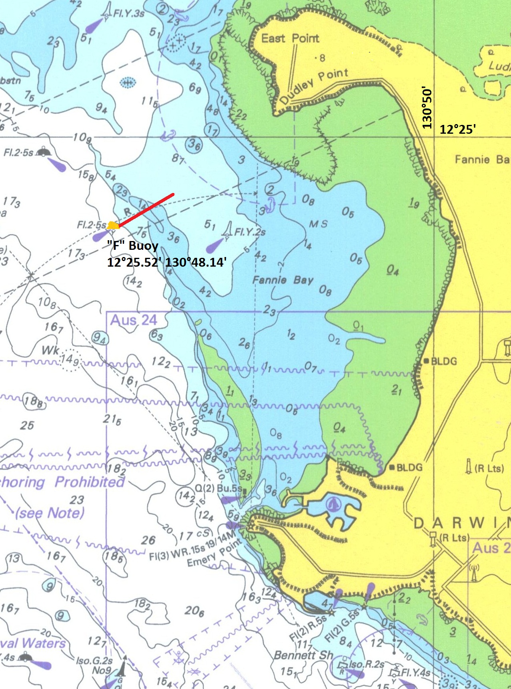

Start Line in Darwin

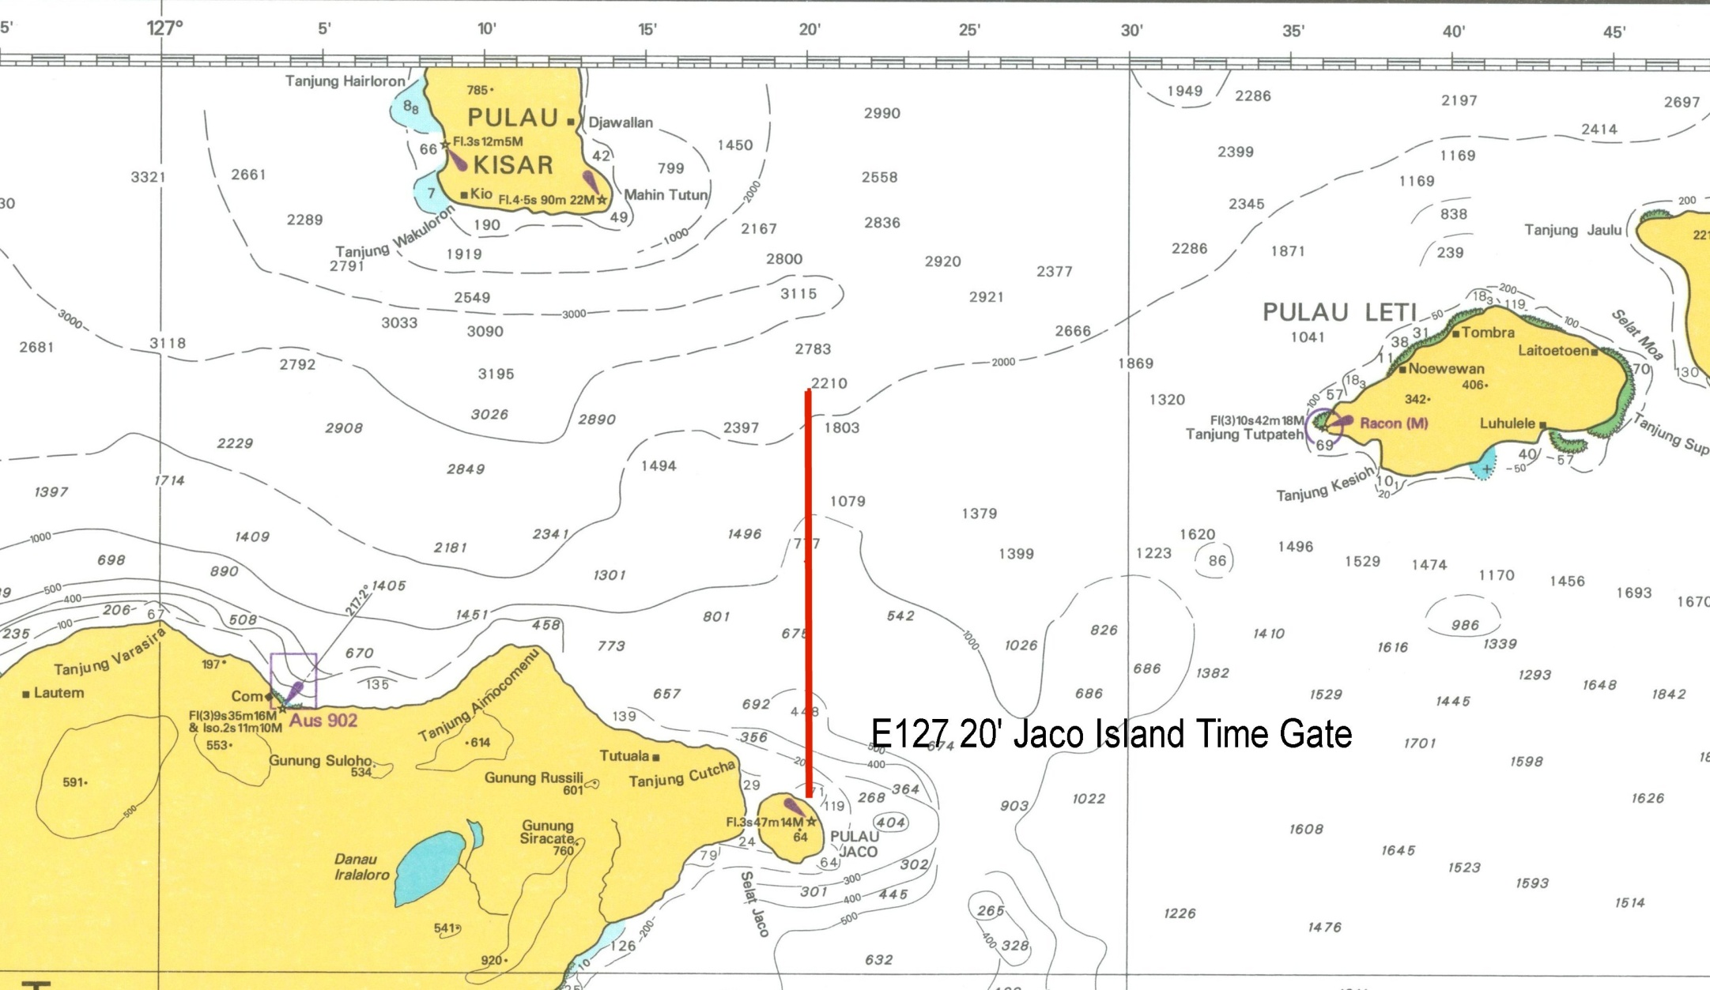
Jaco Island Time Gate

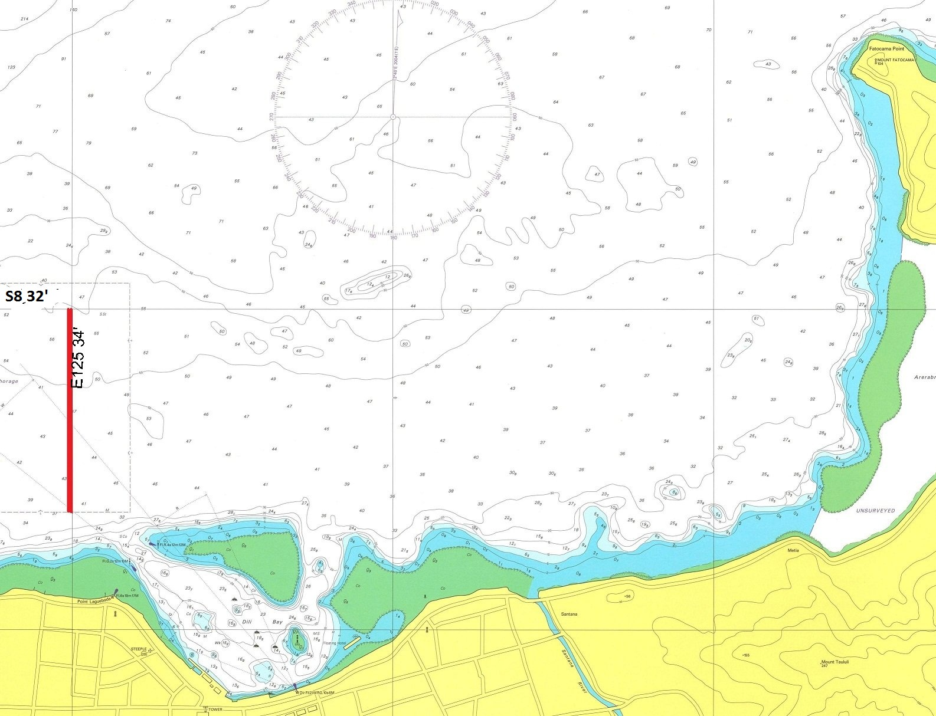
Finish Line in Dili
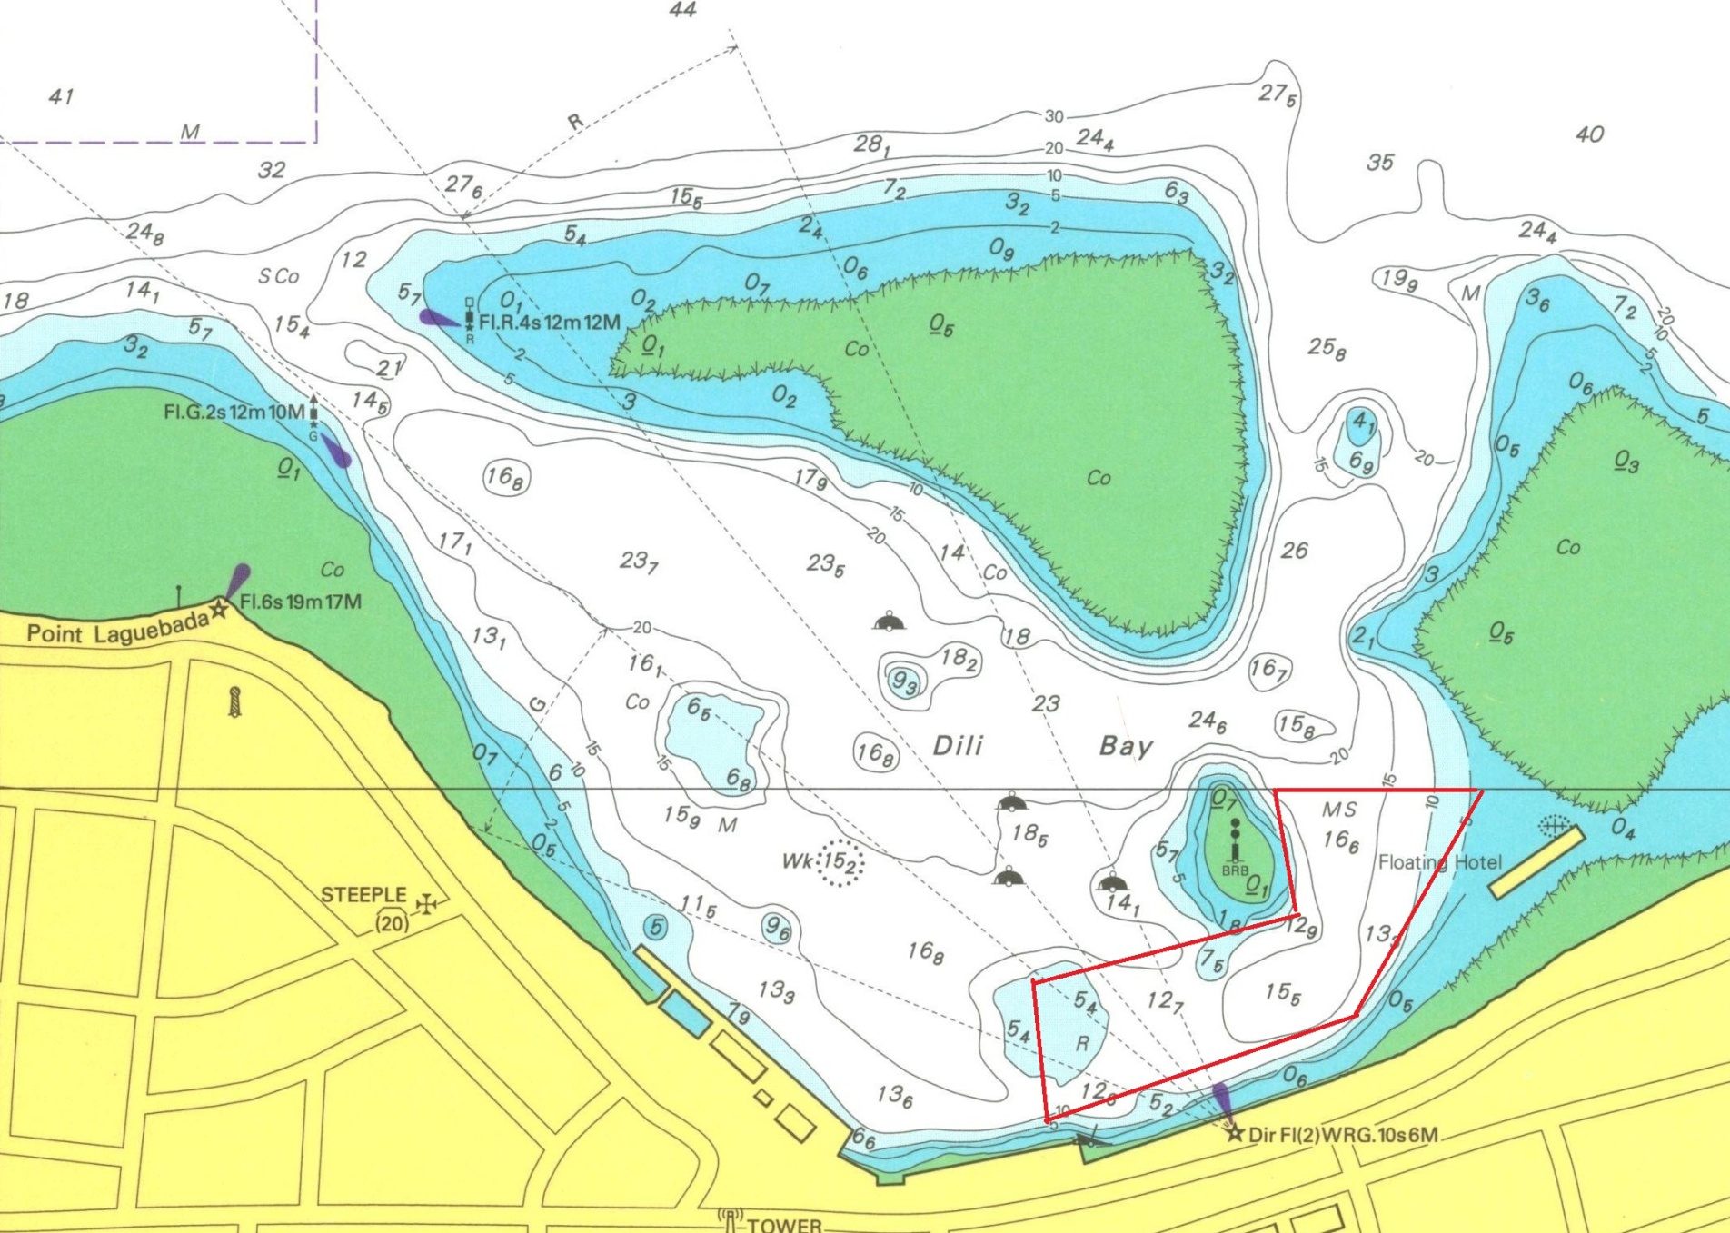
Anchorage Area in Dili

2015 Darwin Dili Yacht Rally  Sailing Instructions | 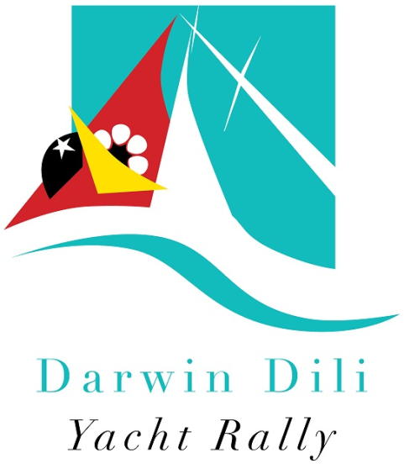
Email: mail@sailtimorleste.org | Web: www.sailtimorleste.org
1 The Course
The course will be from the Start Line in Darwin Harbour, Australia, leaving Jaco Island (located approximately S8° 26’ and E127° 21.2’) to port, to the Finish Line off the city of Dili, Timor-Leste, a distance of 425 NM. Recommended charts for this passage are: Aus 313, Aus 4721, Aus 901 and Aus 26.
A Time Gate is in place after rounding Jaco Island as yachts transit through Longitude E127° 20’.
2 The Start
The Start will be on Saturday 11 July at 1100 hours in the area west of the Darwin Sailing Club. The Start Line will be between the start boat (details advised at the Technical Briefing) which will be in a position approximately 100-200 metres NNW of “F” buoy, located in the vicinity of 12° 25.52’ and 130° 48.14’:
- 1050 Hours Warning Sound Signal; Code Flag "P" will be hoisted
- 1055 Hours Preparatory Sound Signal; Numeral Pennant 1 will be hoisted
- 1059 Hours Code Flag "P" will be lowered
- 1100 Hours Starting Sound Signal; Numeral Pennant 1 will be lowered
All Rally division yachts must keep clear of any yacht in a competitive division in their vicinity, particularly during the starting sequence.
3 The Finish
The Finish Line is a transit of the longitude E125° 34’ between the drying reef bounding the northern edge of Dili Harbour and the latitude S8° 32’. This will be detailed in a chart provided to you at the Rally Technical Briefing. Yachts must take their own finish time (CST) and advise the Dili Rally Office.
In the event that there is no wind along the coast of Timor-Leste, the yacht’s time at the Jaco Island Time Gate may be used to calculate final results.
When you pass the Statue of Christ on Fatocama Point (approximate longitude of E125° 36.2’) as you approach the finish line, please contact the Dili Rally Office in Dili on VHF Channel 77 to obtain any final directions. After you have crossed the finish line, you may then enter Dili Harbour and approach the Rally anchorage. Dili Harbour is surrounded by fringing drying reefs, and must be entered between the designated port and starboard channel markers shown on the chart.
Extreme care should be exercised as you approach and traverse Timor especially close to Dili as it is a busy, working port. There is a continuous stream of large ships, dredges and ferries using (and anchored at approaches to) the port and at night their navigation lights will not always be in accordance with regulations.
In addition, throughout this region when you are close to the coast, extra care is required as there are always large numbers of small unlit fishing canoes and fish traps in these waters that are difficult to see at night and often do not show up on radar.
4 After Finishing
After you finish, please:
- Contact Dili Port on VHF Channel 16 for entry into the Port of Dili, and
- Contact the Dili Rally Office on VHF Channel 77, for directions to the CIQ and anchorage area to complete Timor-Leste Customs, Immigration and Quarantine formalities. Ensure your yacht is displaying the code flag Q and Timor-Leste courtesy flag.
The Customs/Rally anchorage is located at approximately S8° 33.10’ and E125° 34.5’ and will be highlighted on charts provided at the Rally Technical Briefing. Use extreme caution in this area as there is a small drying reef in the vicinity. Inwards CIQP arrangements for clearance of your yacht and crew into Timor-Leste will be advised at the Rally Technical Briefing.
Yachts must advise Dili Rally Office when they have received formal clearance into Timor-Leste.
5 Dili Bay Moorings
Moorings in Dili Bay are currently being inspected and refurbished and may be available for use by Rally yachts free of charge. Use of the moorings is not compulsory and yachts may elect to anchor instead. However Rally Organisers make no warranty as to their fitness for purpose. Yachts which use the moorings do so at their own risk.
Yachts arriving during daylight hours may be met by a tender and guided to available moorings. Yachts arriving by night are advised to anchor until the following day when they may be guided to a mooring.
6 Time Limit
There is no time limit to the Rally. However if you arrive in Dili after 20 July 2015 the special Rally CIQP arrangements may have ceased and personalised assistance for your clearance into Timor-Leste may not be available.
7 Rally Limit

Due to the physical limitations of Dili Harbour, the Rally fleet will be limited to a maximum of 20 yachts. Entries will be accepted as they are received on a ‘first-in, first-served’ basis. Entries which are in excess of the 20 yacht limit will be placed on a waiting-list, pending any cancellations.
8 Divisions
The following divisions are offered and unless you notify us in your entry that you wish to enter a Competitive Cruising Division you will be automatically entered into the Cruising/Rally Division:
- Division I - Monohull Competitive Cruising yachts
- Division I – IRC - In the event that two (2) or more entrants in Division I possess a current IRC rating, an IRC Division will be declared.
- Division II – Cruising/Rally – open to any vessel, including both sail and motor vessels
- Division III - Multihull Competitive Cruising yachts
The Rally Committee reserves the right to make changes to and within Divisions; any such changes will be advised at the Rally Technical Briefing.

9 Handicaps
The Committee will allocate handicaps as follows:
- Yachts in Divisions I and III will be allocated a Time Correction Factor (TCF) based on the yacht's measurements and performance history (if any). The yacht's Elapsed Time will be multiplied by this TCF to give a Corrected Time and placings.
Any yacht with a valid/current IRC certificate or OMR rating must declare this and provide a copy with their entry.
- Division 1 - IRC Division yachts – the TCF on the yacht’s IRC certificate will be adopted to form handicaps for this division.
- Division II yachts – at the discretion of the Committee, may also be allocated a TCF which may be used to guide final award of placings.
10 Prize Pool
The Government of Timor-Leste is proposing to offer a special prize pool for the event, as it has done since 2012. When this is confirmed, the value and allocation of the prize pool will be announced in an update to these Sailing Instructions.
11 Rules
The Rally will be sailed under the International Regulations for the Prevention of Collisions at Sea.
Division II: The use of automatic steering is permitted in Division II, and when engine propulsion is used it must be logged, totalled and declared at the finish in Dili.
All other Divisions: The use of automatic steering is not permitted. Engine propulsion may only be used when rendering assistance to a vessel or crew in distress or to avoid imminent danger to the vessel or crew. Engine use and circumstances of use must be logged and reported as soon as practical to the Rally Committee who will adjudicate on its validity and determine the penalty (if any) to be applied.
See also Point 13 – Rally Reporting Requirements
12 Safety Regulations
The safety of the vessel and its crew is the sole responsibility of the skipper. The Rally is open to Monohull yachts having a waterline length of not less than 7.3 metres and Multihull yachts with a waterline length of not less than 8.0 metres. All yachts shall have completed a non stop passage of at least 200 miles across open sea and must comply with the SOLAS standards.
To assist any skipper a basic safety equipment checklist is available from the Sail Timor-Leste website. The list is compiled from advice from experienced mariners however is not intended to be exhaustive or conclusive for any specific vessel.
Skippers are free to self-assess the requirements of their vessel against the list. Compliance with the list does not, in any way mitigate, release or remove the responsibility or liability from the Skipper to ensure the safety of his/her yacht and crew at all times. Additionally Division I IRC yachts should comply with YA Special Regulations Part 1 - Category 2 Safety requirements
Yacht Trackers: Participants will be provided with a Yellowbrick Yacht Tracker for the 2015 event as a reporting and safety device as a safety tool to monitor and check the fleet. YB Trackers also give families of crew, peace of mind and up-to-date positioning throughout the race. These will be supplied as part of the entry fee.
See also Point 13 – Rally Reporting Requirements

13 Rally Reporting Requirements
Yellowbrick Yacht Trackers will be used as the primary reporting medium while the Rally is in transit.
However, as a secondary back-up, each yacht should possess either a:
- an HF Radio equipped with HF 4483 KHz (primary) / 2524 KHz (secondary) or
- a Satellite Phone or
- a satellite communication device such as a GPS Spot Device or a Delorme inReach Satellite 2-way Communicator
for the purpose of transmitting twice-daily yacht position reports to the Rally Committee until the yacht crosses the Finish Line in Dili. Yachts must also record their transit time through the Jaco Island Time Gate and transmit this to the Rally Committee. In the event that there is no wind along the coast of Timor-Leste, this time may be used to calculate final results.
Any yacht which is unable to comply with these communication requirements is asked to contact organisers as soon as possible. Details of the reporting schedule will be advised at the Rally Technical Briefing. Failure to provide a position report may result in a 6-minute time penalty being imposed by the Rally Committee.
The Dili Rally Office, call sign "Dili Rally” will conduct a morning radio sched on VHF Ch 77 at 0810 hours Dili time each morning, while yachts are in Dili Harbour.
14 Declarations
All owners or skippers of yachts must sign a finish declaration form confirming their finish time and stating whether or not they have complied with these Sailing Instructions and hand it to a member of the Rally Organising Committee within 10 hours of finishing in Dili. This declaration must also include the transit time of the Jaco Island Time Gate referred to in Point 13. Yachts failing to complete a finish declaration form may be recorded as a DNF result.
Protests must be advised to Rally Organisers as soon as possible and no later than submission of the finish declaration form in Dili. Protests will be heard by a protest jury whose decision will be final and any protest received after that time may not be considered.
15 Flags
The yacht's own national flag should be displayed at the stern and the Timor-Leste flag of a size not less that the yacht's own national flag from the crosstrees. When you enter the waters off Dili you must display the code flag "Q" until you have been cleared by Timor-Leste Customs.
Participants in the Rally will be issued with a Darwin Dili Rally Pennant. This pennant should be flown on all yachts going over the start line and until they finally leave Timor-Leste waters.
16 Retirements
Any yacht retiring from the Rally must make every effort to inform the Rally Committee at the earliest opportunity by radio, phone or other means and continue to give position reports until safely in port.
Retiring yachts returning to Darwin after the Rally Start must also notify Australian Customs as soon as possible and prior to arrival.
17 Time Zones
CST is Central Standard Time (Darwin Time) and will be used throughout the Rally for all communications and time keeping and is the time referred to in these instructions, unless specified otherwise. CST is GMT +9:30, Dili time is GMT +9:00.

18 Entry and Rejection of Entries
Entries must be made via the on-line entry form provided on the website, and will not be considered complete until all necessary documents have been provided and the entry fee paid.
The Rally Committee reserves the right to reject any entry at any time up to the Preparatory Signal, in which case the entry fee or part thereof may be refunded.
19 Sponsors Advertising
Yachts may seek and obtain sponsorship and advertise it in whatever form they choose.
20 Presentations and Welcome Function
Details and times will be confirmed at the Rally Technical Briefing prior to departure from Darwin. A noticeboard of events will be located as you come ashore in Dili.
21 Entry, Crew and Yacht Documentation
On-line entry instructions and entry fee information can be found at http://www.sailtimorleste.org/entry Yachts expressing interest in the Rally will be advised when on-line entries open in 2015 via email. Instructions for out-going Australian Customs and Immigration clearance will be advised to confirmed entrants by email.
An AUD$250 entry fee applies per yacht. This entry fee includes an AUD$100 donation to the Rally's Marine Education Scholarship to promote skills development and capacity building to support Timor-Leste’s marine tourism industry.
A 30-day entry Visa on Arrival into Timor-Leste will be issued to all participants in the Rally. This visa will cost USD$30 / crew member and will be payable on arrival in Dili for each crew member. Visa extensions can be arranged. Ensure all crew members seeking to enter Timor-Leste have a valid national passport with an expiry date not less than 6 months from the date of entry into Timor-Leste and at least 2 spare pages in their passport.
Yachts must have a current National Registration Certificate in order to obtain an outgoing Australian Customs Clearance in Darwin and entry into Timor-Leste. For information on obtaining Australian Registration for your yacht, go to: http://www.amsa.gov.au/Shipping_Registration
22 Timor-Leste Sailing Authorisations
All yachts in the Rally will be provided with a Sailing Authorisation entitling them to be in Timor-Leste waters after leaving Dili. This Authorisation is for a period of up to three (3) months and subject to all crew holding valid visas for the term of the Authorisation.
23 Yachts Returning to Australia
Yachts returning to Darwin after completion of the Rally:
- must notify Australian Customs prior to arrival. Australian Customs require that yachts arriving in Australia give notice of arrival at least 96 hours before arrival at their first port in Australia; severe financial penalties can be imposed on yachts which do not. Refer to the Australia Customs Service regulations here
- must comply with Australia’s quarantine regulations and inspection requirements. Refer to quarantine regulations here Note: the Australian Quarantine and Inspection Service also charge a fee to inspect a vessel arriving from overseas (including vessels registered in Australia). Further charges apply if the inspection is carried out outside of normal working hours.
- should be aware that the Northern Territory Government has also instigated regulations which will require all yachts to be inspected prior to entering a marina in Darwin. This inspection is generally free. Further information is available here
24 Additions or Alterations
Any additions or alterations to these instructions will be advised at the Rally Technical Briefing.
25 Indonesian Waters

Any yachts wishing to travel into Indonesian waters or ports require appropriate cruising and security permits. These must be obtained prior to departure from Darwin.

Yachts may enter the 2015 Darwin Dili Yacht Rally and also join the 2015 Sail Indonesia Rally
- The Darwin Dili Yacht Rally starts two (2) weeks prior to the Sail Indonesia Rally which leaves Darwin on 25 July. This will allow enough time for Dili Rally participants to spend a short while in Timor-Leste and its waters before sailing across the north coast of Timor Island onto Kupang in West Timor, joining up with the Sail Indonesia fleet arriving in Kupang from Darwin. For more information go to www.sailindonesia.net
- Yachts participating in both events should depart Dili/Timor-Leste waters in time to reach Kupang in West Timor to coincide with the arrival of the Sail Indonesia fleet from Darwin, currently estimated to be 28-31 July 2015.
- For yachts participating in both rallies, an informal cruise from Dili to Kupang is being organised. This will include a short stopover at the Timor-Leste enclave, Oecusse, which is located on the north coast of West Timor (approximate co-ordinates S09° 10' E124° 20'). Oecusse (also known as Pante Makassar) is almost equidistant from Dili and Kupang (approximately 90 NM from Dili and from Kupang).
- Sail Timor-Leste and Sail Indonesia work co-operatively to facilitate arrangements for yachts which wish to enter both events. For yachts first participating in the Darwin Dili Yacht Rally, there is a reduced entry fee for the Sail Indonesia Rally as you will not be in Darwin for a number of pre-Sail Indonesia events. Contact either mail@sailtimorleste.org or mail@sailindonesia.net for further information.

Yachts wishing to travel to Indonesia independently of Sail Indonesia or other organised events will need to organise appropriate cruising and security permits. Further information on this may be obtained from mail@sailtimorleste.org - we can assist with these arrangements.
26 Yachts entering the Rally from other ports

Yachts wishing to depart Australia from ports other than Darwin e.g. Nhulunbuy, can do so by special arrangement with the organisers. Similarly, any yachts wishing to join the Rally in Dili from other foreign ports e.g. Bali, can do so. Again, this is through special arrangement with the organisers.

Yachts entering the Rally from ports other than Darwin may participate in Rally communication scheds and Rally functions and benefits but will not be eligible for the award of placings or prize pool.

Further Notes:
- All positions and co-ordinates are approximations only and cannot be relied upon for the purposes of navigation. The safety of the vessel and its crew is the sole responsibility of the skipper and all normal navigational aids, systems and precautions should be used.

- All care has been taken in the preparation of this document; it contains the best information available to the Organising Committee at the time however the situation and regulations can change without notice. We do our best to keep informed of the latest information updating all documents on a regular basis, although it is up to the individual skippers to ensure they meet all Government requirements.

2015 Darwin Dili Yacht Rally - Online Entry Instructions and Checklist
The online entry procedure consists of six steps, each of which is a vital part of the process. Please make sure you step through the process and read the information provided carefully. See links on the right of the web window to step through the process. If you have any difficulty at any time with on-line entry, please email us immediately.
SUPPORT: Email to mail@sailtimorleste.org is our preferred method of communication for questions or additional information about the Darwin Dili Yacht Rally.

ENTRY DEADLINES:
Entries should be completed by 14 June 2015 and will be subject to the Rally limit described in the Sailing Instructions. Entries will be managed on a 'first in-first served' basis, unless you have made prior arrangements with the organisers. If there are any changes of details in your entry or additional information after your entry has been submitted, you must advise us by email to mail@sailtimorleste.org The Outward Crew List information is not required until 30 June 2015. This information is only required for your Timor-Leste Sailing Authorisation (after you leave Dili). Again, any variations to the Outward Crew List after this date must be emailed to mail@sailtimorleste.org

STEP 1: PREPARE THE INFORMATION YOU NEED
It is important that you have collected together the information required prior to filling in the form. If the required information is not entered correctly, your entry may not be accepted. You will also need to have your method of payment organised. See the checklist link: http://www.sailtimorleste.org/index.php/entry/online-entry-checklist

STEP 2: UNDERSTAND THE SAILING INSTRUCTIONS
You will be required to confirm that you have read and understood the Sailing Instructions and that the entry is made subject to the conditions set out in the Sailing Instructions. If you are unable to comply with some elements of the Sailing Instructions, please email mail@sailtimorleste.org identifying where you are unable to comply. Your entry will be assessed by the Rally Committee, which will communicate with you by email.

STEP 3: CREATE AN ACCOUNT
You need a login to gain access to the Darwin Dili Yacht Rally on-line entry forms. To create an account:
1. Click on Login/Logout (see link on the right) and then select Create an Account. A registration form will be displayed.
2. Enter your name, username (your choice), email address, password (your choice) and reconfirm your password. Click on Register.
3. You will receive an email confirming an account has been created and confirming the username and password you selected. To activate the account, you need to follow the instructions in the email.
4. You may then return to the login page (in 1. Above) and login to your account using your username and password. Once you have logged in you will see additional links to the Yacht Entry Form and Crew List Form.

STEP 4: COMPLETE THE ONLINE ENTRY FORM AND CREW LIST
Proceed to the online Yacht Entry Form (link on right) fill it out with the information you have prepared and submit it. Note: If you cannot fully complete this form, fill out what you can and save it. You may then return to it at a later time, using your log-in provided to you when you registered.
You will also need to provide details of the yacht's Skipper and Crew into and out of Dili. Click on the Crew List icon in the entry form to generate this. You can add partial crew information, save it and return to complete it at a later time if you wish. Note: All foreigners seeking to enter Timor-Leste on a temporary visa are required to have a valid national passport with an expiry date not less than 6 months from the date of entry into Timor-Leste.

STEP 5: MAKE YOUR PAYMENT
The AUD250 refundable entry fee should be paid to:
- Bank Name: Commonwealth Bank
- Branch Name: Darwin
- Account name: Adelina Varella Braddrige
- BSB No.: 065901
- Account No.: 11057993
- Swift Code: CTBAAU2S
Please include your Yacht’s Name on the receipt confirming payment of the entry fee to the above account so we can match it with your entry. The AUD250 Entry Fee includes a donation of AUD$100 to the Marine Education Scholarship to promote skills development and capacity building to support Timor-Leste’s marine tourism industry. A 30-day entry Visa costing USD$30 will be payable on arrival in Dili for each crew member.
In the event that your yacht is unable to participate in the Rally due to unforeseen circumstances, the Entry Fee will be refundable in full, less any expenses incurred at the date of withdrawal.

STEP 6: EMAIL YOUR SUPPORTING DOCUMENTATION
Electronic copies of the following documents are required as part of your entry for 2015 Darwin Dili Yacht Rally. Entries will not be considered complete until all attachments and information have been received.
- A digital scan of your yacht's current Official Ship’s Registration (both sides);
- A digital scan of the details page of all crew passports, including the skipper;
- A digital passport-style photo of the skipper/captain;
- A digital photo of the vessel; and
- A scanned copy of the receipt supporting your payment of the AUD250 entry fee. Please include your Yacht’s Name on the document.
- If you answered YES to having a current IRC or OMR rating, a copy of this rating certificate is also required.
All scans should be in colour and scanned at least at 100 DPI (but no more than 300 DPI) and in JPG format. If it is a digital photograph, please make it with a light plain background. Electronic copies of all supporting documentation should be emailed to mail@sailtimorleste.org ; please remember to include your yacht name in the subject line.

WHAT HAPPENS NEXT
The Rally Committee will review the online entry details and match the entry, supporting documentation and accompanying payment as soon as practical.
- If entry, supporting documentation and payment are correct, an email confirmation will be sent out
- If entry, supporting documentation and/or payment are not complete a follow up email will be sent out
Names of confirmed entries will be listed on the website. If the entry is still not complete, the listing on the website will be shown in RED as follows: ***Yacht Name***
Note: Entrants will receive further information in the lead up to the Rally. This will include email communications and information provided at the Technical Briefing.
A Check List for Rally Entry can be found at http://www.sailtimorleste.org/index.php/entry/online-entry-checklist

Yachts Participating in BOTH Darwin-Dili and Sail Indonesia Rallies

Sail Timor-Leste and Sail Indonesia work co-operatively to facilitate arrangements for yachts that wish to enter both Rallies. (Note: you do not have to follow the Sail Indonesia schedule to participate in their Rally – you can choose your locations, timetables and exit ports

The Darwin Dili Yacht Rally starts on 11 July 2015, two (2) weeks prior to the Sail Indonesia Rally leaving Darwin on 25 July. This will allow enough time for Dili Rally participants to spend a short while in Timor-Leste and its waters before sailing across the north coast of Timor Island onto Kupang in West Timor, joining up with the Sail Indonesia fleet arriving from Darwin.

Note: You must arrive in Indonesia at Kupang at the same time as the group of yachts arrive from Darwin (28-31 July 2015) so your CAIT (Cruising Permit), visas, paperwork and incoming documentation can be processed with all the other yachts.

If you arrive in Kupang after these dates, Sail Indonesia staff will have moved onto other locations and not be able to assist you with your incoming paperwork; you would need to manage Indonesian Customs and other entry arrangements by yourself. In the past this has meant employing a local agent in Kupang to assist you with entry arrangements, which can cost in the order of USD$250.

The arrangements to participate in both Rallies are as follows:

1. When entries for the Rallies open in early 2015:

a) Complete your entry for the Darwin Dili Yacht Rally indicating your intention to join the Sail Indonesia Rally afterwards:http://www.sailtimorleste.org/index.php/entry/online-entry

b) Then enter the Sail Indonesia Rally - email to mail@sailindonesia.net

Organisers of both Rallies will liaise to ensure we maintain an accurate record of yachts participating in both events.

2. For yachts first participating in the Darwin Dili Yacht Rally, Sail Indonesia charges a reduced entry fee of AUD$250 for the Sail Indonesia Rally as you will not be in Darwin for a number of pre-Sail Indonesia events. However, if you do not end up participating in the Darwin Dili Yacht Rally, you will need to pay the full entry fee amount to Sail Indonesia prior to departing Darwin. (The 2015 entry fee for the Sail Indonesia Rally is AUD$525).

3. Once you have fully completed entry in the Sail Indonesia Rally, you will be able to apply for Social visas for entry into Indonesia. This can be done in Darwin before you leave or in Dili after you arrive; the process can take up to 5 working days. Further information on Indonesian visas can be found at http://www.sailindonesia.net/rally/rallypermit.php.

4. An electronic copy of your Indonesian Cruising Permit (CAIT) will be provided to you before you leave Darwin on the Dili Rally provided you have completed your Sail Indonesia entry before 6 June 2015. The original of your Indonesian Cruising Permit (CAIT) will be taken up to Kupang and will be waiting for you on arrival. The reason for this is that the original CAITs usually do not arrive in Darwin until a few days before the start of the Sail Indonesia Rally.

5. Sail Indonesia staff will provide an information briefing to yachts undertaking the Dili Rally following the Dili Rally Technical Briefing on Sunday 5 July. In this briefing you will receive the information that would normally be made available to yachts at the Sail Indonesia Technical Briefing in Darwin.

Finally, if you will be returning to Darwin/Australia after cruising through Indonesia, you are welcome to return to Timor-Leste waters and call in at Dili etc for another stay if you wish – you may need to renew visas etc but this is not difficult. On return to Dili, the first point of call is the Dili Port Authority/Harbour Master. You may email mail@sailtimorleste.org of your intentions to return to Dili and we will advise Dili Port; however you will still need to contact them directly on arrival to arrange your clearances.

If you have any queries regarding this information, please contact us at the above email addresses.

Other Notes:

a) There is no need to obtain visas for Timor-Leste in advance. All crews participating in the Rally will be issued with a 30-day Visa on Arrival in Dili (costing USD$30 per person).

b) En route from Dili to Kupang, yachts are welcome to stopover at the Timor-Leste enclave, Oecusse, which is located on the north coast of West Timor (approximate co-ordinates S09° 10' E124° 20'). Oecusse (also known as Pante Makassar) is almost equidistant from Dili and Kupang (approximately 90 NM from Dili and from Kupang).

Oecusse will be automatically included on your Timor-Leste Sailing Authorisation so there is no need to decide about this destination in advance.

Information for yachts travelling to Australia - let us know you're coming
The Master of a vessel arriving in Australia is required by law to give notice of impending arrival not later than 96 hours before arrival. Penalties may apply for failure to do so.
If the journey, from a place outside Australia, is likely to take less than ninety-six (96) hours then the below sliding scale is used based on the steaming time from the previous foreign port (section 64(5)(b)(i) of the Customs Act- Customs Regulations section 27).
Item | Likely duration of journey | Specified period
1 | 72 hours or more but less than 96 hours | 72 hours
2 | 48 hours or more but less than 72 hours | 48 hours
3 | 24 hours or more but less than 48 hours | 24 hours
4 | Less than 24 hours | 12 hours
There are several agencies interested in your arrival - principally Customs, Quarantine and Immigration.
96 hours notice may be given by either;
- Sending an email to yachtreport@customs.gov.au
- Sending a fax to +61 2 6275 5078
- Phoning the Australian Customs National Communications Centre on +61 3 9244 8973
You will need to provide the following information
- The name of your craft
- Craft's Country and Port of Registration
- Your intended first port of arrival
- Your estimated arrival time
- Your last four ports
- The details of people on board including name, date of birth, nationality and passport number
- Details of any illness or disease recently encountered
- If you have any animals on board
- If you have any firearms on board

(*) Crew Members departing Dili by sea are not subject to Departure Tax. Crew Members departing Dili by air are subject to a USD10 Departure Tax, payable at the Airport, after Check-In and prior to clearing Immigration. (**) Visa Extensions. Each Crew Member will be issued with a 30 day Visa on arrival at a cost of USD30. Visas may be extended prospectively for a further 30 days + 30 days (ie 60 days in total) for a further payment of USD35 per 30 day extension. The total costs for a visa for a 90 day stay is USD100

